|  |  |  |
| --- | --- | --- |
|  | | |
|  |  | shim |
|  | | |



Dear Parent,

Welcome to Cub Scout Pack ______. Thank you for selecting our pack to join!

To help you and your child get off to a great start in Cub Scouting, we would like to invite you to attend our Welcome Night on:

Date: _________________________________________

Time: _________________________________________

Location: ______________________________________

At this meeting, we will:

* Share more of the details about how the dens and pack operate.
* Explain the pack budget and show how the popcorn sale helps your family and our pack pay for our Cub Scout program.
* Share some of the exciting activities and camp opportunities that you and your family can look forward to.
* Give you information about training that is available online and in our area.

Before this meeting, you can also check out the Dan Beard Council website at [www.danbeard.org](http://www.danbeard.org) for more information about local Scouting.

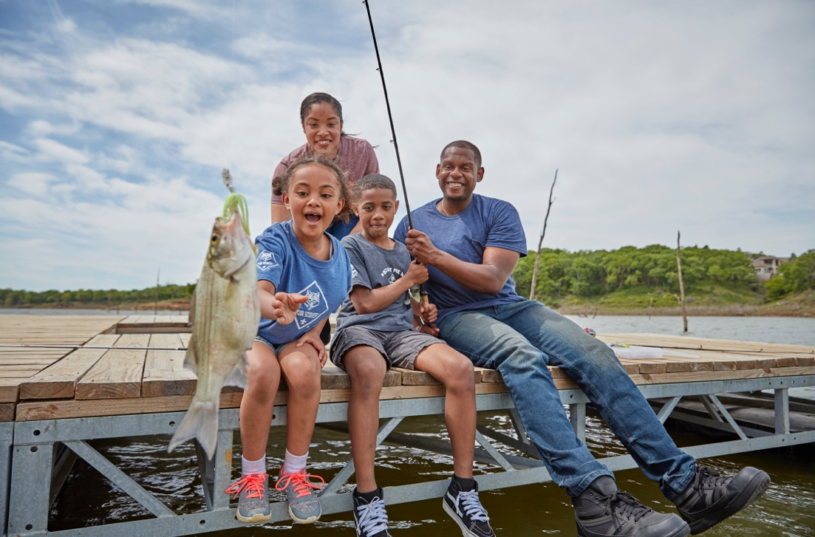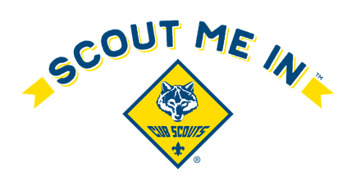

**GoCubScouts.com**



**GoCubScouts.com**

Dear Parent,

Welcome to Cub Scout Pack ______. Thank you for selecting our pack to join!

To help you and your child get off to a great start in Cub Scouting, we would like to invite you to attend our Welcome Night on:

Date: _________________________________________

Time: _________________________________________

Location: ______________________________________

At this meeting, we will:

* Share more of the details about how the dens and pack operate.
* Explain the pack budget and show how the popcorn sale helps your family and our pack pay for our Cub Scout program.
* Share some of the exciting activities and camp opportunities that you and your family can look forward to.
* Give you information about training that is available online and in our area.

Before this meeting, you can also check out the Dan Beard Council website at [www.danbeard.org](http://www.danbeard.org) for more information about local Scouting.